**Terraform Assignment**

Problem: As we know that terraform is an provisioning tool use to provision resource in the cloud.

Solution: We need to deploy an azure vm with local variable in terraform. Create a bastion host using terraform and using null provisioned upload the ssh key in bastion host. And connect the vm with those ssh key.

Run the terraform using following command:

Terraform init & validate

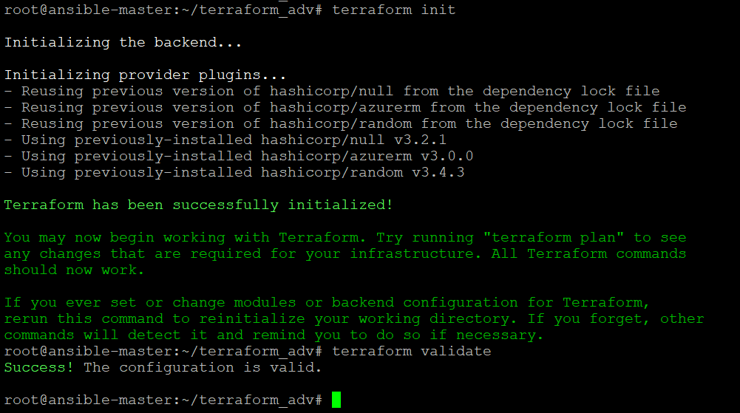

Terraform plan

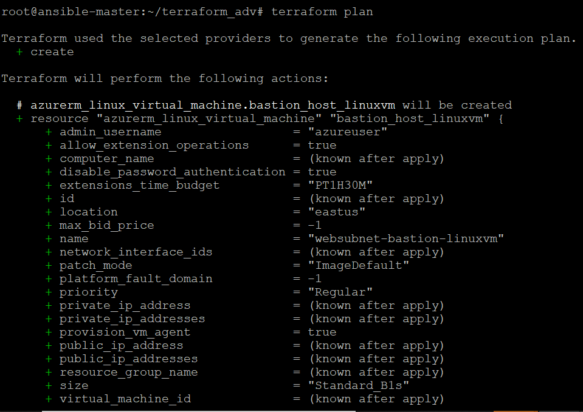

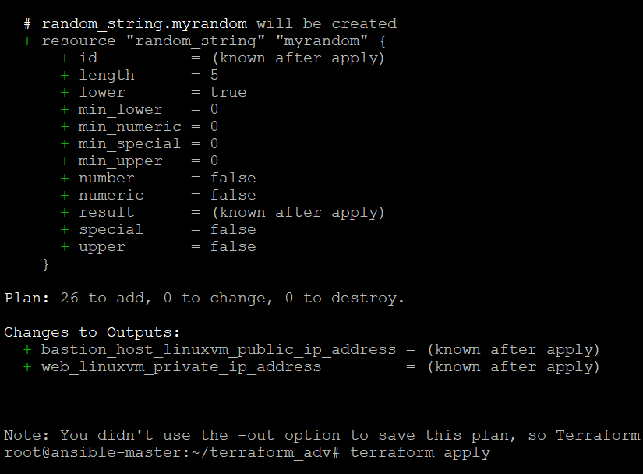

Terraform apply

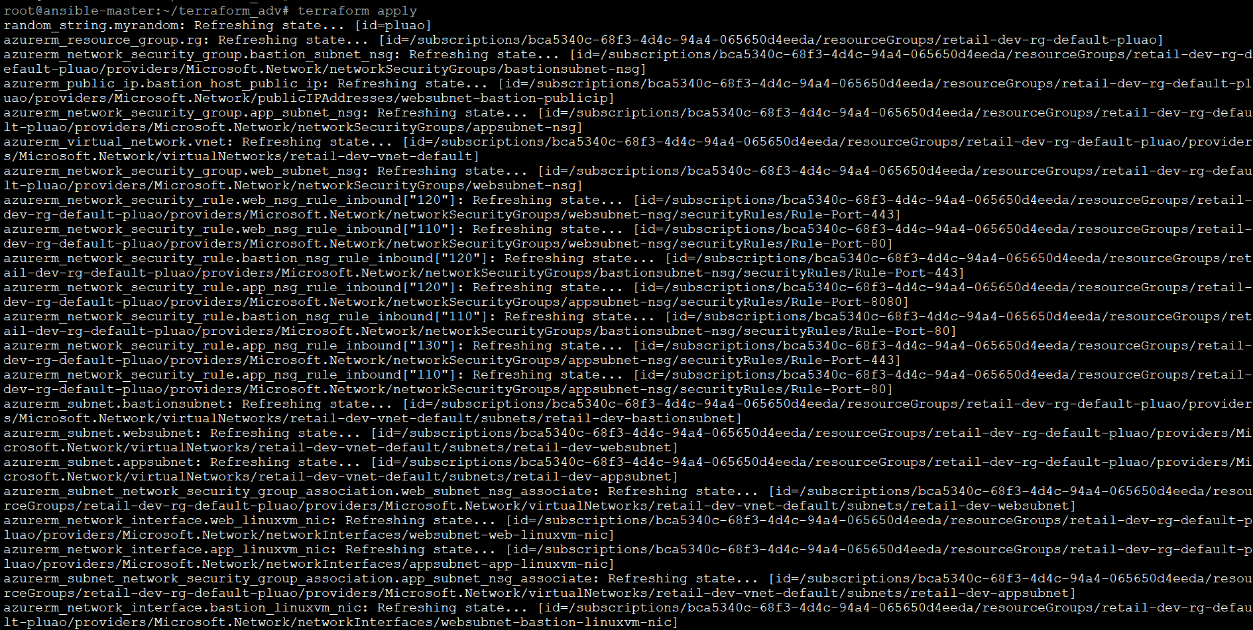

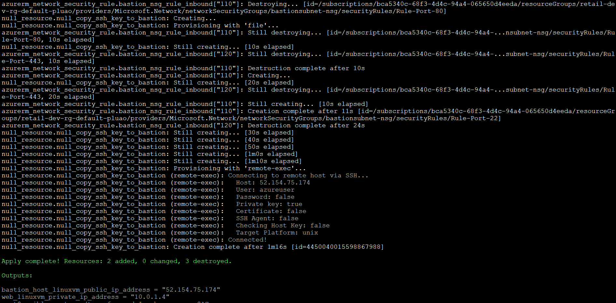

Connect to bastion host using public ip:

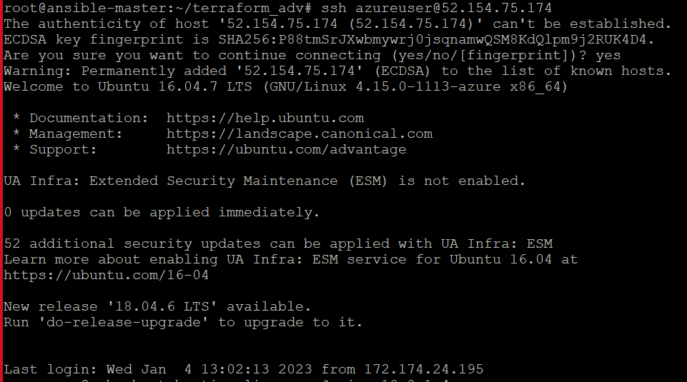

Ping the bastion host using private ip:

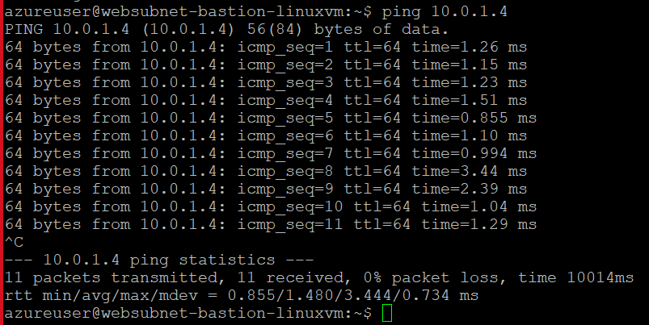

Virtual Machine ss: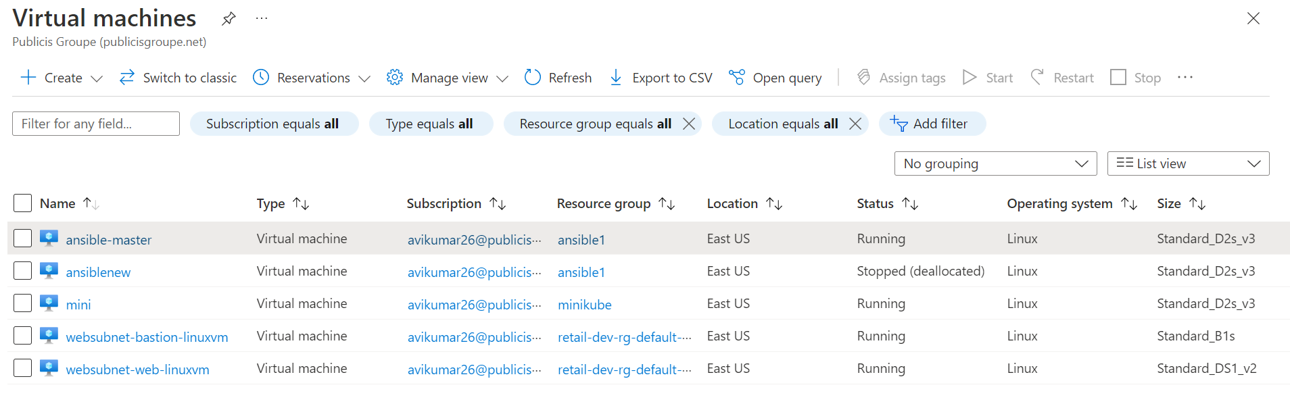

Resource group:

